Team Porky

Phase 0

Interview Session 1:

08/24/2017

8:00-9:00 AM

Interviewer: Justin

Interviewee: Jacob

Observer: Phillip

Duration: 00:32:00

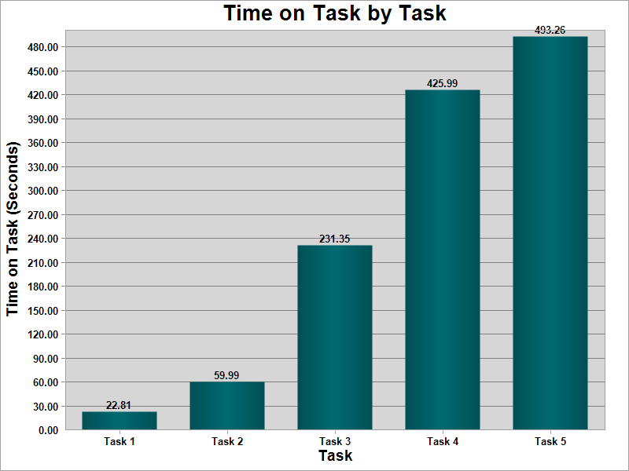

|  |  |  |  |  |  |  |  |  |  |
| --- | --- | --- | --- | --- | --- | --- | --- | --- | --- |
| |  | | --- | | Asked again for what text was | | Spellcheck would be nice | | Step 6 may have wrong time because the start time is unclear | | User finds align button misleading | | User forgot part of instruction | | User is having trouble typing Submit | | User is unsure of which label is to which | | User lost as to next task | | User question about kind of form used in step 3 | |

Interview session 02:

08/29/2017

8:00-9:00 AM

Interviewer: Jacob

Interviewee: Sam

Observer: Justin

Duration: 00:04:00

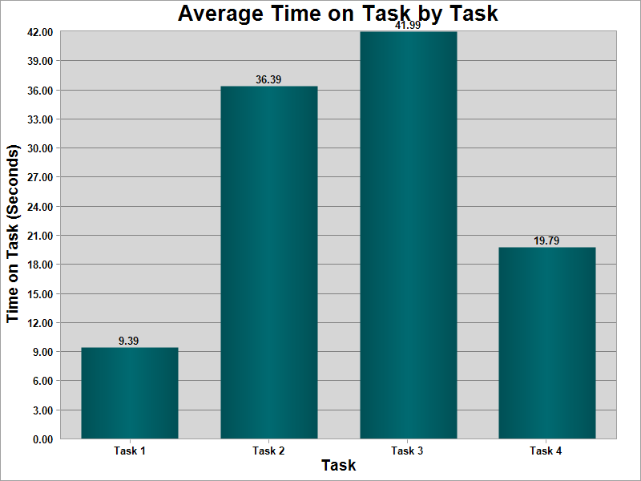

*No time to take any notes

Interview session 03:

08/30/2017

8:00-9:00 AM

Interviewer: Sam

Interviewee: Phillip

Observer: Justin

Duration: 00:06:00

Part 1 –

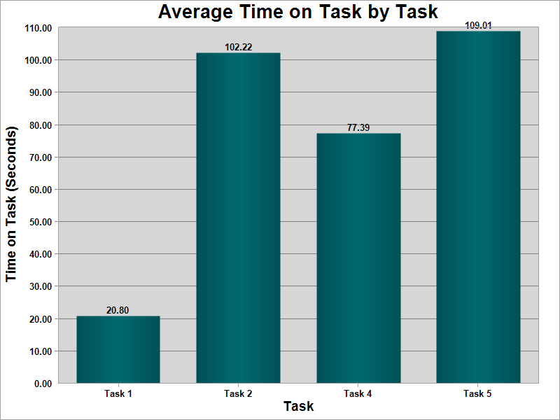

Part 2 -

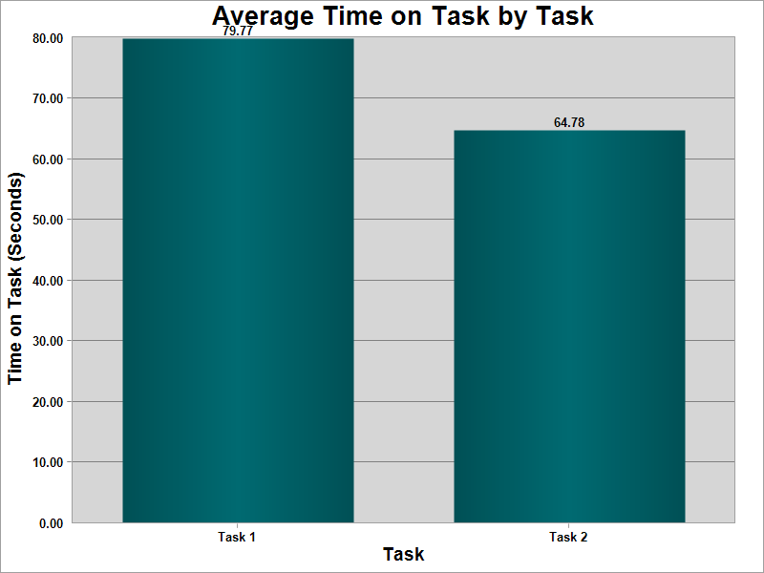

|  |
| --- |
| arrows are hard to draw in a way that registers and the equals sign wouldn't work no matter how he tried to make it until he just continued on with the equation |
| having difficulty writing out the fromulas and actually making the correct symbols appear. |
| his symbols are being registered as different characters all together |
| no button to view history easily, the copy button in the bottom right works well |
| This is a good feature for those that dont know how to type the formula in word on its own. |

Interview session 04:

08/31/2017

8:00-9:00 AM

Interviewer: Phillip

Interviewee: Justin

Observer: Sam

Duration: 00:09:20

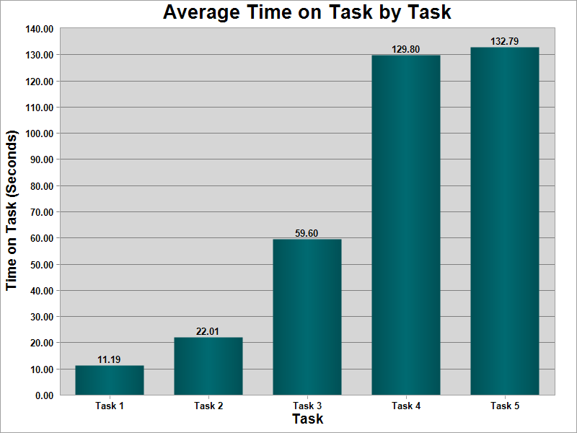

|  |
| --- |
|  |
|  |
|  |
|  |
| found the right corner desk |
| used the wrong corner table |

